**Online Revision cleanup**

Each update to the repository creates a new content revision. As a result, with each update the size of the repository grows.

To avoid uncontrolled repository growth, old revisions need to be cleaned up to free disk resources. This maintenance functionality is called Revision Cleanup. It has been available as an offline routine since AEM 6.0.

With AEM 6.3 an online version of this functionality called Online Revision Cleanup was introduced. Compared to Offline Revision Cleanup where the AEM instance has to be shut down, Online Revision Cleanup can be run while the AEM instance is online. Online Revision Cleanup is turned on by default and it is the recommended way of performing a revision cleanup.

The revision cleanup process consists of three phases:

1. **Estimation**
2. **Compaction**
3. **Clean up**

**Estimation:**

Estimation determines whether to run the next phase (compaction) or not based on how much garbage might be collected.

**Compaction:**

During the compaction phase segments and tar files are rewritten leaving out any unused content.

**Clean up:**

The clean-up phase subsequently removes the old segments including any garbage they may contain.

**How to Run Online Revision Cleanup**

Online Revision Cleanup is configured by default to automatically run once a day on both AEM Author and publish instances. All you need to do is define the maintenance window during a period with the least user activity. You can configure the Online Revision Cleanup task as follows:

1. Go to Tools - Operations - Dashboard - Maintenance or point your browser to: <http://localhost:4502/libs/granite/operations/content/maintenance.html>

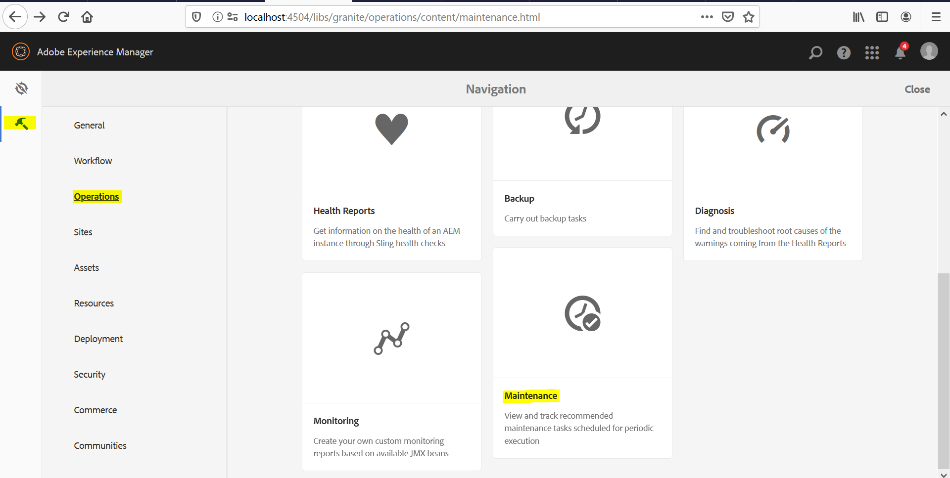

1. Click on the maintenance window and should be able to see the options like shown below.

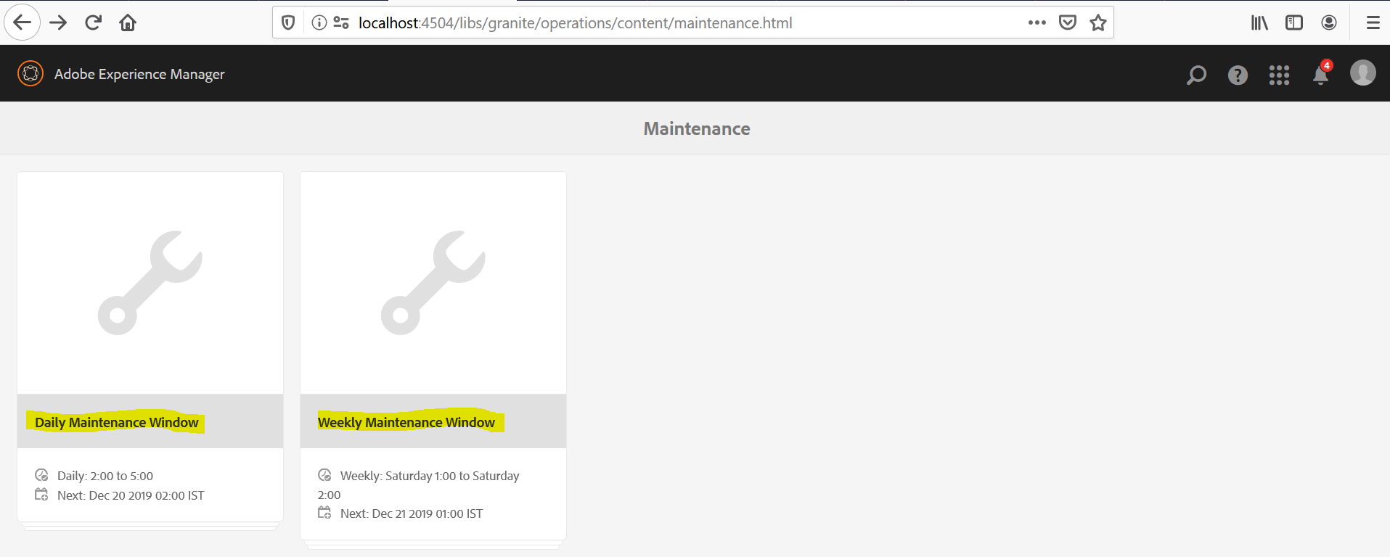

1. Hover over Daily Maintenance Window and click on Settings icon.

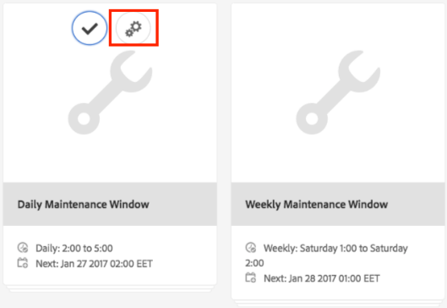

1. Enter the desired values (recurrence, start time, end time) and click **Save**.

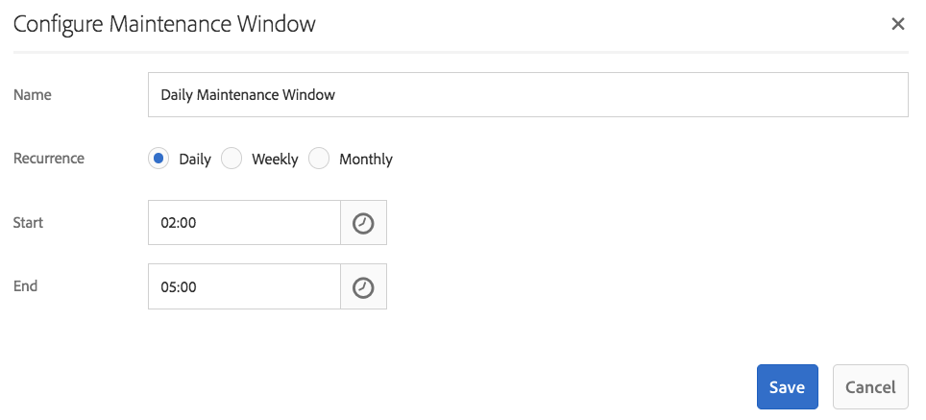

Alternatively, if you want to run the revision cleanup task manually, you can:

1. Go to **Tools - Operations - Dashboard - Maintenance** or browse directly to http://serveraddress:serverport/libs/granite/operations/content/maintenance.html
2. Click the **Daily Maintenance Window**.
3. Hover over the **Revision Cleanup** icon.
4. Click **Run**.

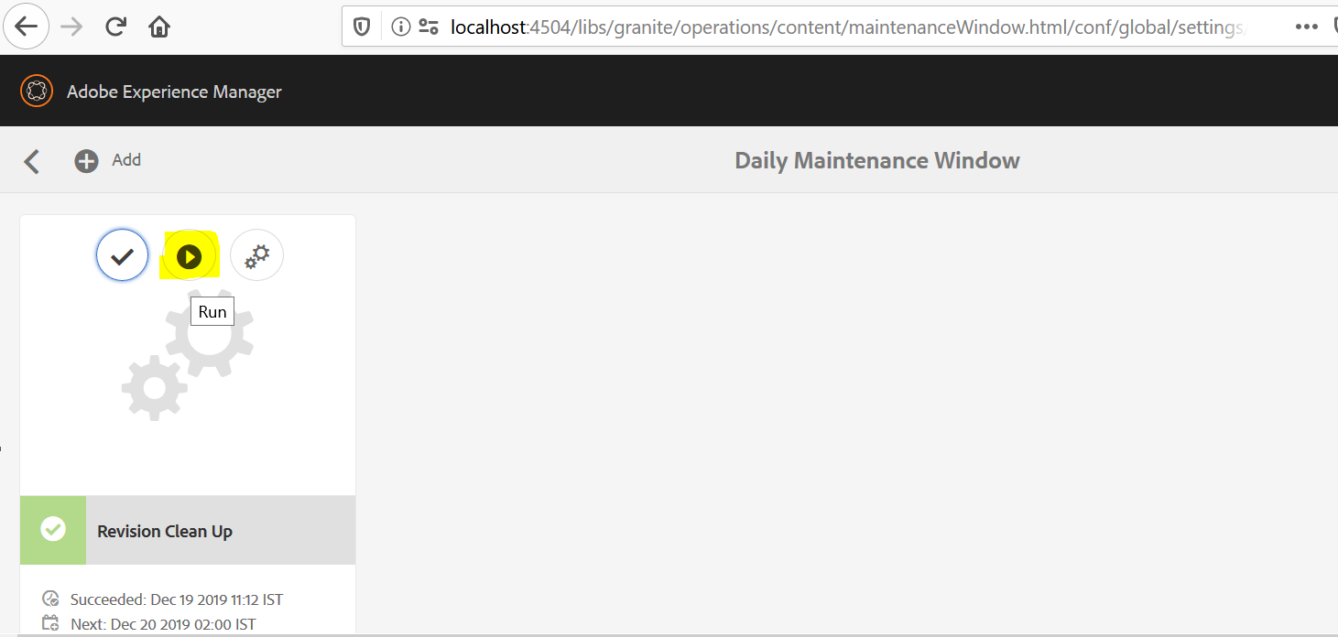

**Note:** Each time you run revision cleanup a new generation is created and kept on the disk.

Offline revision cleanup keeps one generation while online revision cleanup keeps two generations.

So, when you run online revision cleanup **after** offline revision cleanup the following happens:

1. After the first online revision cleanup run the repository will double in size. This happens because there are now two generations that are kept on disk.
2. During the subsequent runs, the repository will temporarily grow while the new generation is created and then stabilize back to the size it had after the first run, as the online revision cleanup process reclaims the previous generation.

In addition to revision clean up, we can also setup Version Purge task.

**Steps:**

1. Go to **Tools - Operations - Dashboard - Maintenance** or browse directly to http://serveraddress:serverport/libs/granite/operations/content/maintenance.html
2. Click the **Daily Maintenance Window**.
3. Click on the Add icon.

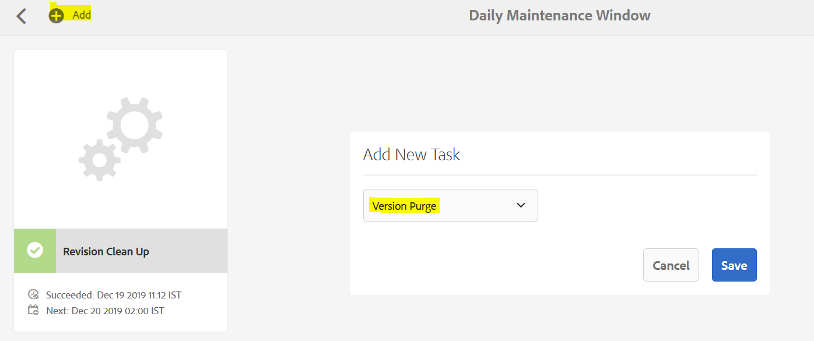

There will be only one task left, which is Version Purge. Because, we have already added Revision clean up task.

1. After saving the changes, we would be able to see 2 tasks under Daily Maintenance Window.

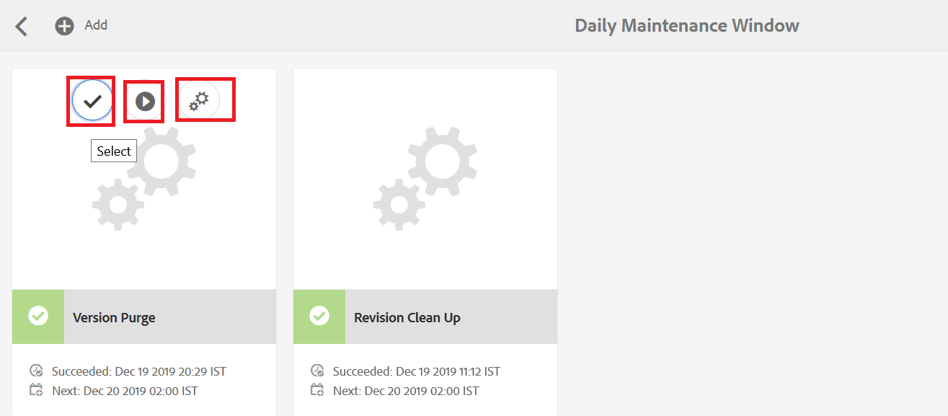

1. To select the task
2. To run the version purge task.
3. To configure the version purge task.

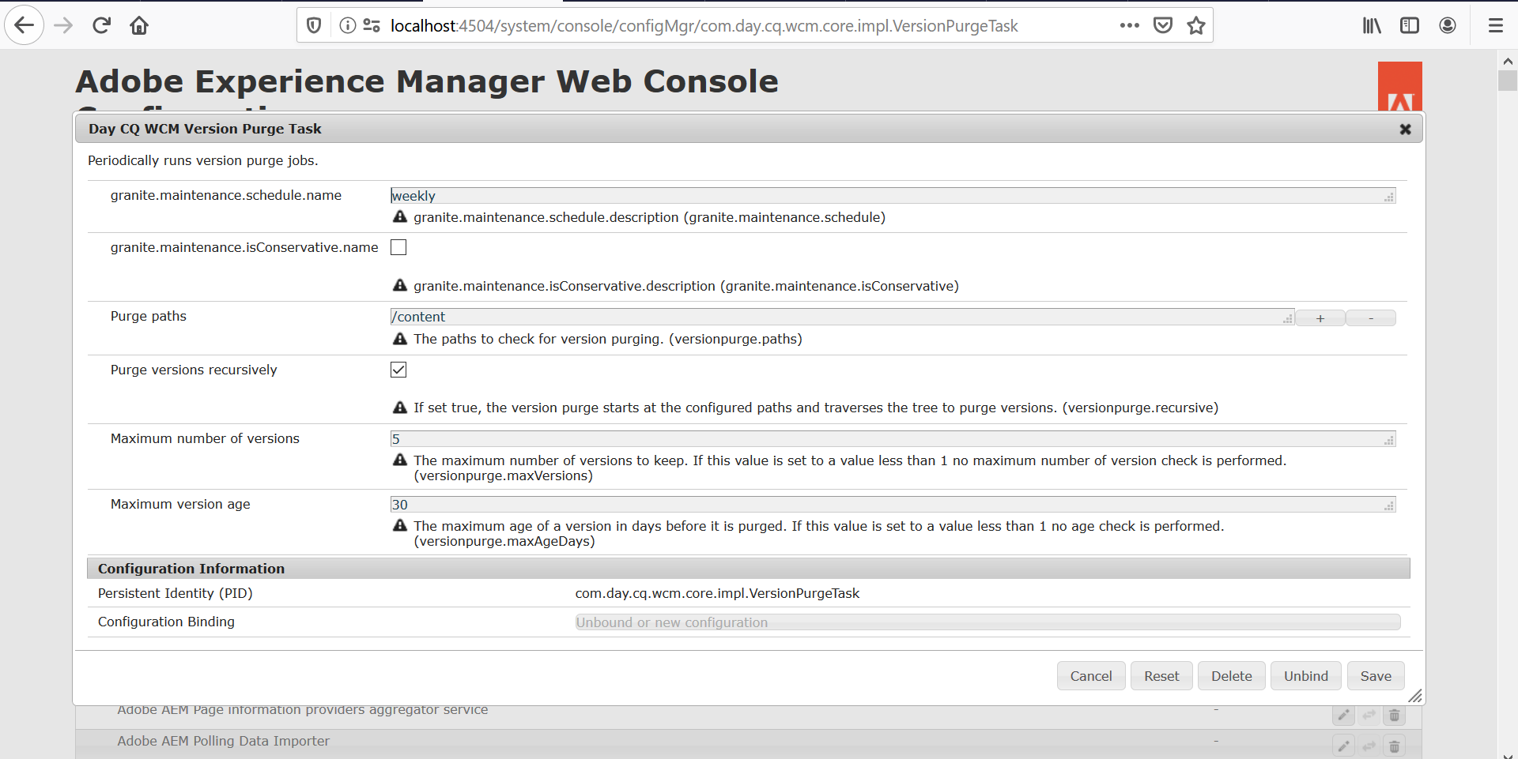

Note: We can check the logs to see, if the clean-up process is running or not in log file.

Check for “**TarMK**” key word and we will find the logs.